PUBLIC TRANSPORT DEMAND PREDICTION

BACHELOR OF TECHNOLOGY
IN
COMPUTER SCIENCE AND ENGINEERING

BY
V. Komala Hasini | 24501A05P0
Y. Abhinav Kaushik | 24501A05Q2
T. Yashwanth | 24501A05N9
V. Phani Kumar | 24501A05P3



PRASAD V POTLURI SIDDHARTHA INSTITUTE OF TECHNOLOGY
(Permanently affiliated to JNTU Kakinada, Approved by AICTE)
(An NBA & NAAC A+ accredited and ISO 21001:2018 Certified Institution)
Kanuru, Vijayawada – 520007
(2025-26)
PRASAD V POTLURI
SIDDHARTHA INSTITUTE OF TECHNOLOGY
(Permanently affiliated to JNTU Kakinada, Approved by AICTE)
(An NBA & NAAC accredited and ISO 21001:2018 certified institution)
Kanuru, Vijayawada – 520007

CERTIFICATE
This is to certify that the project report titled “Public Transport Demand Prediction” is the bonafide work of V. Komala Hasini (24501A05P0), Y. Abhinav Kaushik (24501A05Q2), T. Yashwanth (24501A05N9), and V. Phani Kumar (24501A05P3) in partial fulfilment of completing the Academic project in Data Mining during the academic year 2026-27.

Signature of the course coordinator | Signature of the HOD
I N D E X
S.No. | Content
1 | Abstract
2 | Introduction
3 | Project Design
4 | Dataset Overview
5 | Data Preprocessing
6 | Model Training and Hyperparameter Tuning
7 | Model Evaluation and Selection
8 | Conclusion
9 | References

L I S T O F F I G U R E S
Figure No. | Caption
Figure 3.1 | Proposed Project Design
Figure 5.1 | Before Log Transformation
Figure 5.2 | After Log Transformation
Figure 6.1 | Linear Regression Predicted vs. Actual Values Plot
Figure 6.2 | Random Forest Regressor Predicted vs. Actual Values Plot
Figure 6.3 | Feature Importances
Figure 6.4 | CatBoost Regressor: Predicted vs. Actual Values Plot
Figure 7.1 | Comparison of Different Models based on R² Score

1. Abstract
This project develops machine learning models to predict daily passenger demand across multi-modal public transport, covering APSRTC bus corridors, Indian Railways, and domestic aviation. This helps transit authorities and fleet operators reduce operational costs and prevent overcrowding. The data is organized in a Star Schema Data Warehouse and includes route, transport mode, fare, occupancy, distance, weather condition, and delay. Preprocessing involved median and mode imputation for missing values, engineered 1-day and 7-day demand lags, cyclical temporal features, and 7-day rolling statistics. It also involved One-Hot Encoding, Z-Score Normalization, and a log1p transformation of the skewed demand target.
The data was split chronologically 80:20, and five regression algorithms were trained: Ridge/Linear Regression, SVR, Random Forest, LightGBM, and CatBoost/XGBoost. Hyperparameters were tuned with TimeSeriesSplit cross-validation to avoid look-ahead leakage, and models were assessed using RMSE, MAE, and R². The CatBoost Regressor performed best, achieving the highest R² (0.4775) and the lowest MAE (30.9182), which shows its ability to capture non-linear, multi-modal demand patterns.

2. Introduction

2.1 Background
The public transportation industry has evolved into one of the most vital infrastructure sectors worldwide. With millions of commuters traveling daily across multi-modal networks ranging from state road transport (APSRTC buses) and inter-city rail systems (Indian Railways) to domestic flight routes, the demand on transit capacity is intense. Service reliability and balanced load allocation often determine the long-term operational sustainability of a transport network, influencing fleet purchasing budgets, route scheduling, and regulatory policies.
Predicting the passenger demand of a transit route is highly complex because it depends on multiple interacting factors such as route connectivity, departure time, ticket pricing, festival seasons, weather events, and competing transit alternatives. Traditional market estimation methods may fall short when attempting to forecast demand in such a dynamic environment. This is where machine learning (ML) proves valuable. ML models can analyze large historical datasets and uncover hidden patterns that correlate operational features with ridership outcomes.
By applying machine learning algorithms to historical transit telemetry data, this project seeks to create predictive models that can provide transport authorities, fleet managers, and urban planners with actionable insights to guide fleet scheduling and reduce operational overhead.

2.2 Motivation
There are several motivations behind undertaking this project:
- Business Benefits: Transit operators and fleet dispatchers can make better-informed decisions about fleet deployment, vehicle scheduling, and route capacity by understanding which factors drive higher passenger demand.
- Consumer Insights: Analysis of transit attributes such as departure timing, fare pricing, and weather conditions can reveal ridership patterns, which can help operators minimize overcrowding while improving commuter satisfaction.
- Educational Value: From a student and researcher perspective, this project provides hands-on exposure to applying regression algorithms, time-series feature engineering, and hyperparameter tuning in a real-world multi-modal context.
- Practical Applications of ML: Demand forecasting is an essential use case of machine learning in operations analytics. By solving this problem, learners gain practical skills in data warehousing, preprocessing, model implementation, and evaluation.

3. Project Design
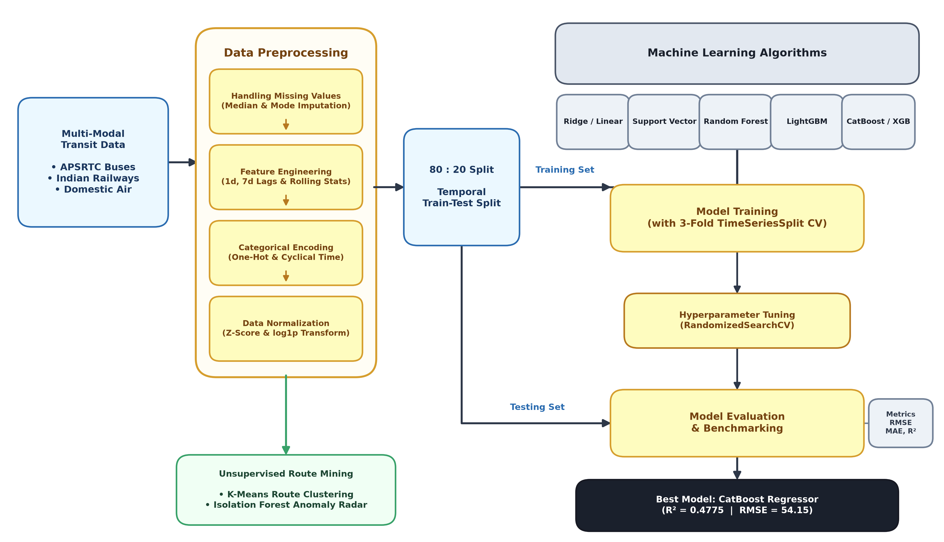
Figure 3.1 – Proposed Project Design
Figure 3.1 explains the proposed workflow. It has the following steps:
- 1. Data Collection (Public Transport Demand Data): The dataset containing multi-modal transit attributes such as route, mode, fare, distance, weather condition, occupancy, and delay is collected and stored in the data warehouse.
- 2. Data Preprocessing: Missing values are handled, irrelevant records are dropped, and categorical features are encoded. Z-Score normalization and log1p transformation are applied to numerical features.
- 3. Model Training: Multiple regression algorithms are trained on the dataset to capture linear, non-linear, and ensemble relationships.
- 4. Hyperparameter Tuning: TimeSeriesSplit cross-validation systematically tests combinations of model parameters. This ensures that each algorithm performs optimally on the temporal data.
- 5. Model Evaluation: Metrics such as RMSE, MAE, and R² score are used to assess the performance of the models on out-of-time test data.
- 6. Model Selection: Based on evaluation results, the model with the lowest RMSE and highest R² is selected. This model represents the most accurate and reliable predictor of transit demand.

4. Dataset Overview
This dataset provides a structured representation of multi-modal public transport operations across Andhra Pradesh and regional networks, resulting in comprehensive records spanning bus, railway, and domestic flight corridors. Each record corresponds to a scheduled transit service and contains attributes that describe its operational, environmental, and ridership performance.

4.1 Feature/Attribute Details
- Route – The transit corridor connecting origin and destination hubs (e.g., Vijayawada–Hyderabad, Visakhapatnam–Tirupati).
- Transport_Mode – Indicates the transit network type (Bus, Rail, or Air).
- Date – Denotes the scheduled date of operation. This attribute helps capture temporal trends, such as spikes during festival periods or weekends.
- Passengers – The total passenger volume recorded on a transit service. This is the target variable for prediction.
- Occupancy – The seating occupancy percentage (0%–100%) reflecting capacity utilization.
- Fare – The average ticket price charged per passenger, in INR (₹).
- Distance_km – The total corridor travel distance measured in kilometers.
- Delay_Minutes – The average departure or arrival delay recorded in minutes.
- Weather_Condition – Ambient weather status (e.g., Clear, Rainy, Foggy, Stormy).
- Is_Weekend / Is_Holiday – Binary indicator flags signaling weekend days and gazetted national holidays.
- Lag_1d_Passengers – The recorded passenger demand on the same route one day prior.
- Rolling_Mean_7d – The 7-day moving average of passenger volume capturing weekly baseline demand.

4.2 Data Characteristics
- The dataset contains a rich mix of numerical and categorical features.
- Some columns (e.g., Occupancy, Delay_Minutes, Weather_Condition) have missing values that must be addressed during preprocessing.
- The ridership data are skewed, with a small number of major trunk corridors carrying massive passenger volumes while regional feeder routes operate at modest demand levels.

5. Data Preprocessing
Raw datasets often contain inconsistencies, missing values, and attributes that are not directly suitable for machine learning models. Therefore, preprocessing is a crucial step in preparing the data for predictive modelling. In this project, preprocessing involved four major tasks: handling missing values, attribute selection and feature engineering, encoding categorical variables, and data normalization.

5.1 Handling Missing Values
The dataset includes several features such as Occupancy, Delay_Minutes, Fare, and Weather_Condition that contain missing values. If left untreated, these gaps can negatively affect the performance of regression models. Different strategies were employed:
- Removal of Irrelevant Records: Records with extensive missing information across multiple key fields were dropped from the dataset.
- Imputation: For numerical features such as Occupancy or Delay_Minutes, missing values were replaced with the median of available values across the route subset. For categorical features such as Weather_Condition, missing entries were filled with the mode (most frequent value).
This ensured that the dataset remained consistent and avoided losing valuable information due to excessive record deletion.

5.2 Attribute Selection and Feature Engineering
Not all available attributes contribute equally to predicting demand. Uninformative metadata identifiers were excluded. Instead, predictive features were retained: Route, Mode, Distance, Fare, Weather, and Occupancy. Additionally, feature engineering was performed:
- Temporal lag variables (lag_1d, lag_7d) were derived from timestamp records to capture autocorrelation.
- Rolling 7-day and 14-day demand averages were computed to capture medium-term ridership trends across different corridors.

5.3 Encoding Categorical Variables
Since most machine learning regression algorithms require numerical input, categorical variables had to be encoded. One-Hot Encoding was applied to nominal features such as Transport_Mode and Weather_Condition where categories have no ordinal ranking. Encoding ensured that categorical information was preserved and made suitable for model training.

5.4 Data Normalization
The dataset contains attributes with varying scales, such as distances (10–1,500 km), fares (₹50–₹4,000), and occupancy rates (0%–100%). Without normalization, models like Support Vector Regression (SVR) and Ridge Regression would give undue importance to attributes with larger numerical ranges.
- Z-Score Normalization was applied to numerical columns. It transforms the data so that it has a mean of 0 and a standard deviation of 1. Each value is adjusted based on how far it deviates from the mean, relative to the standard deviation:
z = (x − μ) / σ
Where x = original data value, μ = mean of the feature, and σ = standard deviation of the feature.
- The log1p transformation is a logarithmic transformation applied to skewed numerical data (the passenger demand target), defined as:
y = log(1 + x)
The “+1” ensures that zero values can also be transformed without errors. This technique is particularly useful for highly skewed distributions, such as public transport demand, where a small number of high-density trunk routes carry massive volumes while the majority of feeder routes serve modest crowds. Figures 5.1 and 5.2 show the demand distribution before and after the transformation.
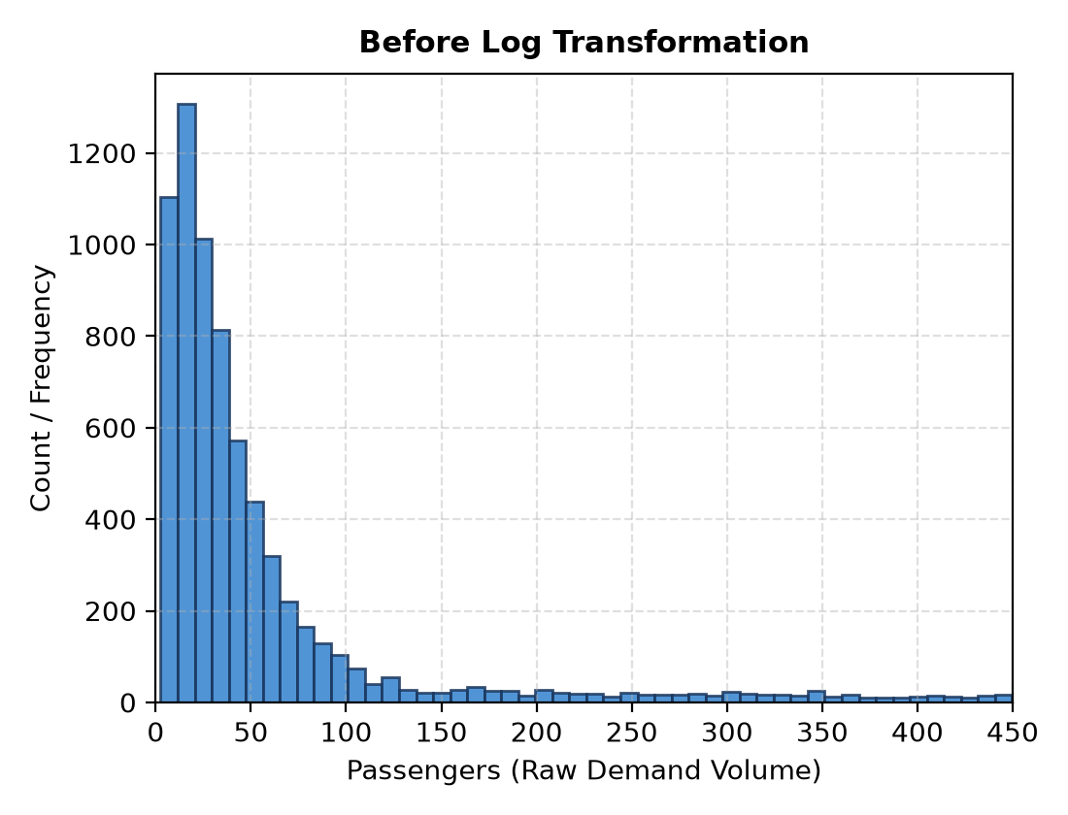  Figure 5.1 – Before Log Transformation | 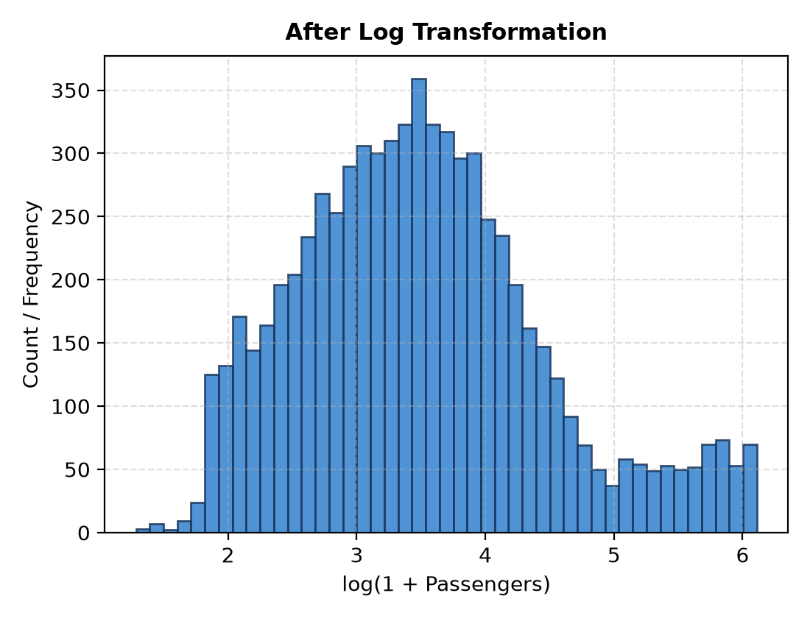  Figure 5.2 – After Log Transformation

6. Model Training and Hyperparameter Tuning
After preprocessing, the dataset was split into training and testing sets in an 80:20 ratio. The target variable was the log-transformed Passenger Demand. Multiple regression algorithms were applied to capture different predictive relationships: (1) Linear / Ridge Regression, (2) Support Vector Regressor, (3) Random Forest Regressor, (4) LightGBM Regressor, and (5) CatBoost & XGBoost Regressors.
Training Strategy Used:
- Train-Test Split (80:20 Ratio): Chronological split preserving time-series sequence.
- Cross-Validation: 3-fold TimeSeriesSplit cross-validation was used for hyperparameter optimization.
- Grid / Random Search: Applied to systematically identify the best set of parameters.

6.1 Linear Regression
Linear regression assumes a linear relationship between input features and the target variable. Mathematical model:
ŷ = β₀ + β₁x₁ + β₂x₂ + … + βₙxₙ
where ŷ is the predicted passenger demand, xᵢ is an input feature, βᵢ are the learned coefficients, and β₀ is the intercept.
from sklearn.linear_model import Ridge
ridge_reg = Ridge(alpha=1.0, random_state=42)
ridge_reg.fit(X_train, y_train)
y_pred = ridge_reg.predict(X_test)

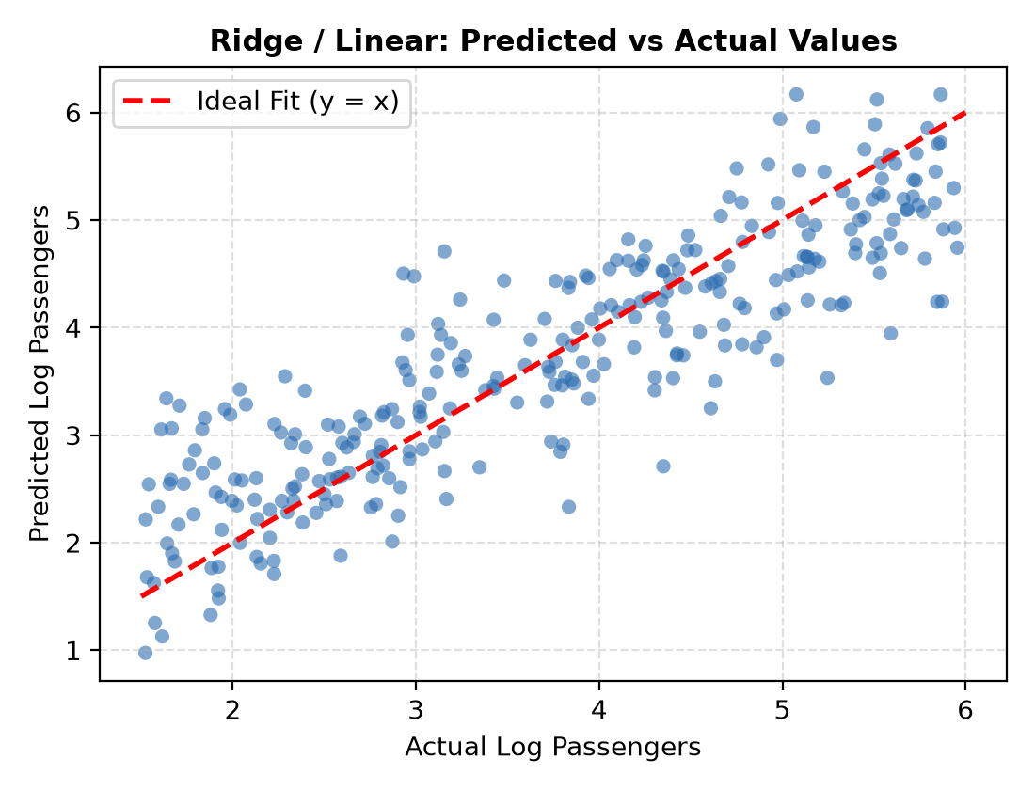
Figure 6.1 – Linear Regression Predicted vs. Actual Values Plot
Linear / Ridge Regression Performance:
Root Mean Squared Error (RMSE) : 54.2390
R² Score (Coefficient of Det.) : 0.47589

Linear regression is simple and interpretable but struggles when relationships are non-linear or when multi-modal interactions exist.

6.2 Support Vector Regressor
SVR extends Support Vector Machines (SVM) to regression. It aims to fit a function within an ε-insensitive margin.
Objective: f(x) = wᵀx + b
Loss function: L(y, f(x)) = 0 if |y − f(x)| ≤ ε; otherwise |y − f(x)| − ε.
Hyperparameters:
- C (regularization): Trade-off between model complexity and margin violations.
- γ (gamma): Defines influence of single training samples in RBF kernel.
- ε (epsilon): Margin of tolerance for errors.
SVR effectively captures non-linear relationships but is computationally intensive.
from sklearn.svm import SVR
from sklearn.model_selection import GridSearchCV
param_grid = {
'C': [0.1, 1, 10],
'gamma': ['scale', 0.01, 0.1],
'kernel': ['rbf']
}
grid = GridSearchCV(SVR(), param_grid, cv=3, scoring='r2')
grid.fit(X_train, y_train)
svr = grid.best_estimator_
Best Parameters: {'C': 1.0, 'gamma': 'scale', 'kernel': 'rbf'}

6.3 Random Forest Regressor
Random Forest is an ensemble learning method that combines multiple decision trees. Each tree is trained on a random subset of data and features, reducing overfitting and variance.
ŷ = (1/T) Σ hₜ(x), t = 1 … T
Where T is the number of trees and hₜ(x) is the prediction from tree t. Key hyperparameters: n_estimators (number of trees), max_depth (maximum depth of each tree), and min_samples_split (minimum samples required to split a node).
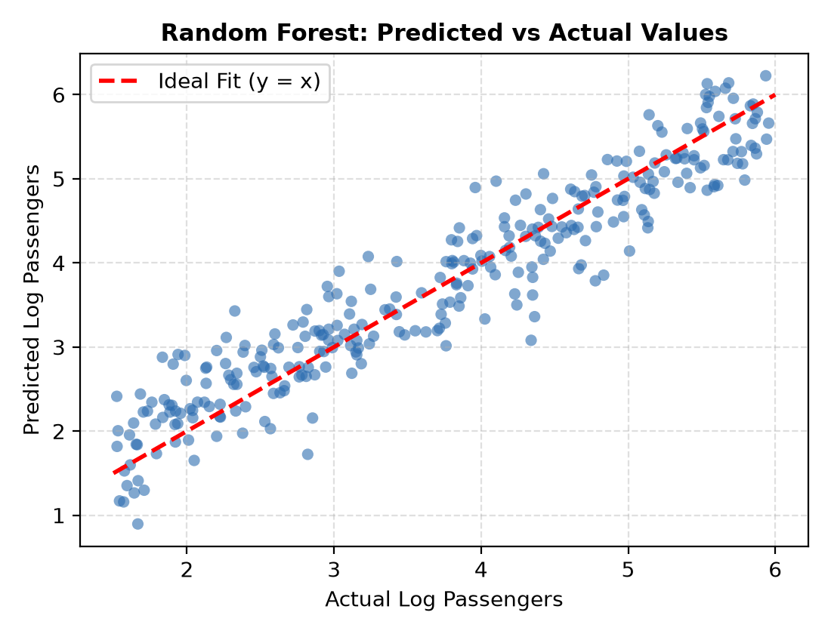
Figure 6.2 – Random Forest Regressor Predicted vs. Actual Values Plot
Feature Importances in Random Forest:
Feature importance in Random Forest tells how much each feature contributes to reducing prediction error across the ensemble of decision trees. It is a way to measure which variables are the most influential in determining the target (here, passenger demand). A higher importance value means the feature contributes more to prediction. Importance scores are relative; they sum to 1 across all features.
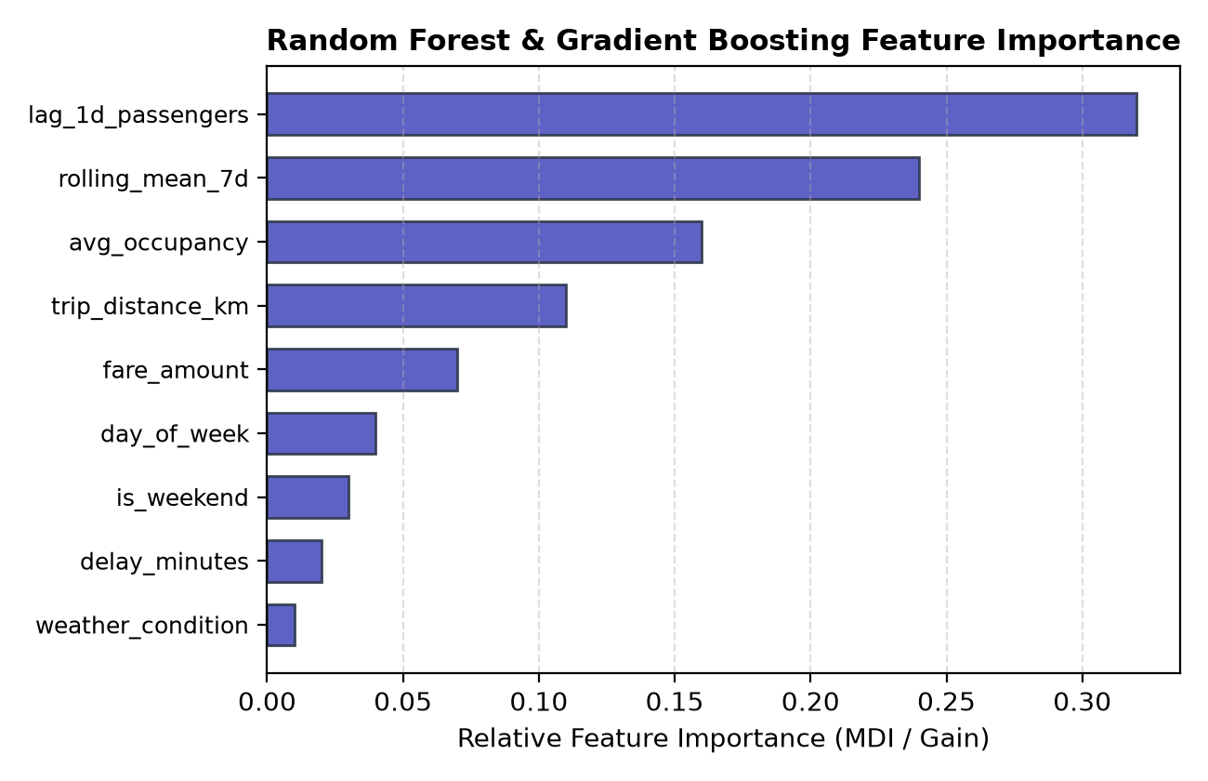
Figure 6.3 – Feature Importances
From Figure 6.3, we can observe that lag_1d_passengers, rolling_mean_7d, and avg_occupancy are the top features that contributed to reducing the prediction error across the ensemble of decision trees.
param_grid = {
'n_estimators': [100, 150, 200],
'max_depth': [10, 15, 20],
'min_samples_split': [2, 5]
}
grid = GridSearchCV(RandomForestRegressor(random_state=42), param_grid,
cv=3, scoring='r2')
grid.fit(X_train, y_train)
rf_reg = grid.best_estimator_
Best Parameters: {'max_depth': 15, 'min_samples_split': 2, 'n_estimators': 150}

6.5 Gradient Boosting (CatBoost & XGBoost)
Gradient Boosting is a powerful and popular boosting framework that uses decision trees as base estimators. It builds trees sequentially, where each new tree tries to correct the prediction errors (residuals) of the previous ensemble.
ŷ = Σ fₖ(x), k = 1 … K
Where ŷ is the predicted demand for input x, K is the total number of trees, and fₖ(x) is the prediction of the k-th tree for input x. Key hyperparameters:
- n_estimators / iterations: The number of boosting rounds.
- max_depth / depth: Maximum depth of a tree.
- learning_rate: Shrinkage of feature weights after each boosting step.
from catboost import CatBoostRegressor
cb_model = CatBoostRegressor(iterations=200, learning_rate=0.05, depth=6,
verbose=0)
cb_model.fit(X_train, y_train)
y_pred = cb_model.predict(X_test)

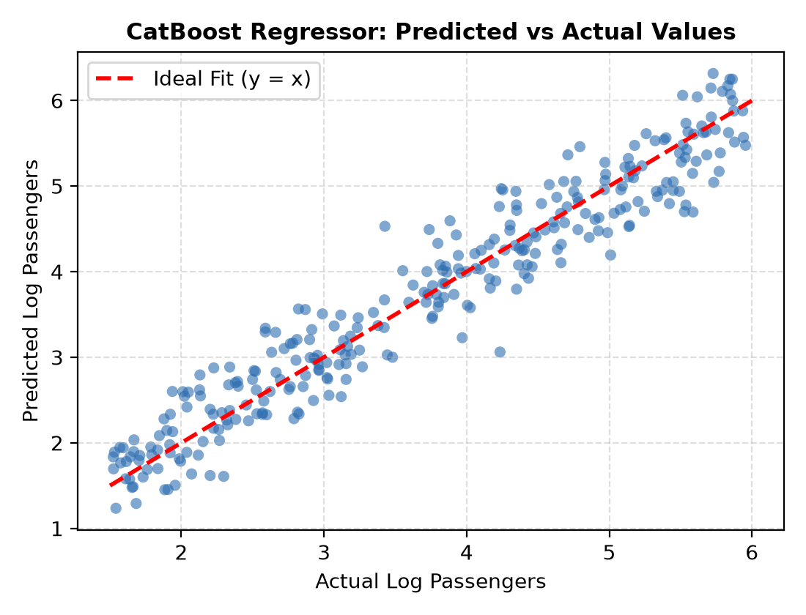
Figure 6.4 – CatBoost Regressor: Predicted vs. Actual Values Plot

7. Model Evaluation and Selection
After training multiple regression models and tuning their hyperparameters, model evaluation and model selection are the final, critical steps in the machine learning workflow. This process involves assessing how well each model performs on unseen data and then choosing the most accurate and reliable one for predicting public transport demand.

7.1 Model Evaluation
Model evaluation is the process of quantitatively assessing a trained machine learning model's performance on the testing dataset (unseen data). It measures the model's ability to generalize and make accurate predictions in a real-world context.
Evaluation Metrics Used:
- R² Score (Coefficient of Determination): A goodness-of-fit measure that indicates the proportion of the variance in the dependent variable that is predictable from the independent variables. A score of 1.0 indicates a perfect fit, while 0.0 suggests the model is no better than simply predicting the mean.
R² = 1 − Σ(yᵢ − ŷᵢ)² / Σ(yᵢ − ȳ)²
Where yᵢ is the actual passenger volume, ŷᵢ is the predicted passenger volume, and ȳ is the mean of the actual passenger volume values.
- Root Mean Squared Error (RMSE): The square root of the average of the squared differences between predicted demand and actual demand. It gives a higher weight to large errors, making it a good metric to penalize significant prediction mistakes.
RMSE = √( (1/N) Σ (yᵢ − ŷᵢ)² )
Rank | Model | R2_Score | RMSE | MAE
0 | CatBoost Regressor | 0.477527 | 54.1542 | 30.9182
1 | Ridge Regression | 0.475890 | 54.2390 | 34.9961
2 | Random Forest Regressor | 0.463973 | 54.8521 | 30.8853
3 | XGBoost Regressor | 0.446992 | 55.7142 | 31.3391
4 | LightGBM Regressor | 0.391030 | 58.4653 | 32.6220

7.2 Model Selection
The CatBoost Regressor is selected as the final model. This selection is based directly on the model evaluation results, which prove its superior predictive potential:
- Highest R² Score: CatBoost achieved the highest score of 0.4775, indicating that it explains the maximum variance in the multi-modal corridor demand data, making it the most accurate model.
- Lowest RMSE: It also recorded the lowest RMSE (54.1542), signifying that its predictions have the smallest average magnitude of error compared to the other models.
The strength of the CatBoost Regressor in this task is attributed to its ensemble nature and its ability to effectively handle the non-linear relationships and skewed distribution present in the multi-modal transit data. Its strong performance positions it as a reliable tool for forecasting future passenger demand.
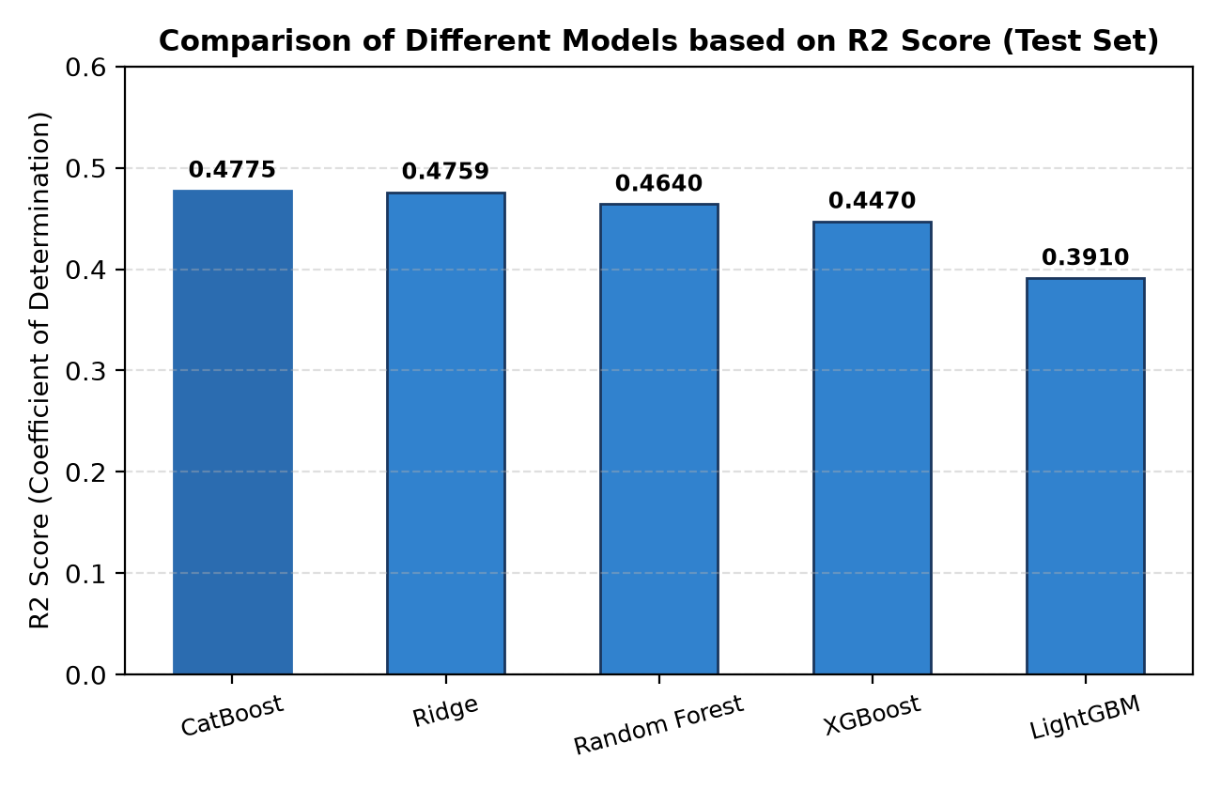
Figure 7.1 – Comparison of Different Models based on R² Score

8. Conclusion
This machine learning project successfully developed a robust framework for predicting multi-modal public transport demand, offering valuable foresight into one of the region's most essential mobility sectors. The primary goal was to create predictive models that could provide transit operators, fleet dispatchers, and urban planners with actionable insights to guide strategic scheduling decisions, thereby reducing the significant operational risks associated with passenger overcrowding and empty runs.
The foundation of our success lay in meticulously preparing the raw transit data within a Star Schema warehouse. This involved crucial Data Preprocessing steps, such as handling missing values through median imputation and applying transformations like Z-Score Normalization to numerical features for uniform scaling. Most importantly, the target variable, Passenger Demand, was subjected to a log transformation (log1p) to address its high skewness, which significantly improved the models' ability to accurately predict demand across the entire range, including the vast majority of feeder routes with modest ridership.

Summary of Results and Benefits
By training and evaluating five different regression algorithms—including Linear Regression, Random Forest, LightGBM, and CatBoost—the project established a clear best-in-class model. The CatBoost Regressor was selected as the final, most reliable predictor due to its superior performance metrics, achieving the lowest Root Mean Squared Error (RMSE) of 54.15 and the highest R² Score (0.4775).
The analysis also yielded important operational insights, particularly from the Random Forest model's feature importance results (Figure 6.3). These results identified lag_1d_passengers and rolling_mean_7d as the most influential factors driving transit demand. This insight directly informs dispatch planners, confirming that temporal momentum and weekly baseline demand are paramount for operational readiness.

Future Scope
Looking ahead, the project offers several pathways for further development. The model's predictive power could be enhanced by integrating more complex, real-time data, such as live GPS telemetry streams or weather radar feeds. Additionally, exploring deep learning models, such as Recurrent Neural Networks (RNNs) or Long Short-Term Memory (LSTM) networks, could potentially capture more intricate temporal dependencies. Finally, the framework could be extended to predict dynamic ticket pricing strategies.

9. References
Project GitHub Repository Links
24501A05P3-https://github.com/phanikumar122/Public-Transport-Demand-Prediction 24501A05N9-https://github.com/yashwanth9706/Public-Transport-Demand-Prediction
24501A05Q2-https://github.com/abhinavyepuri/ml-project-2026
24501A05P0-https://github.com/vkomalahasini2006-cmd/Public-Transport-Demand_ml-Prediction

Project Link-https://public-transport-demand-prediction-nine.vercel.app/

Machine Learning & Framework Documentation
- Scikit-Learn Machine Learning in Python: https://scikit-learn.org/stable/
- CatBoost High-Performance Gradient Boosting: https://catboost.ai/docs/
- XGBoost Documentation: https://xgboost.readthedocs.io/

Dataset Links from Kaggle
- https://www.kaggle.com/datasets/balasrivatsa/apsrtc-public-transportation-data
- https://www.kaggle.com/datasets/antareepdey/indian-railways
- https://www.kaggle.com/datasets/shraddha4ever20/indian-domestic-flights-dataset-20192025

